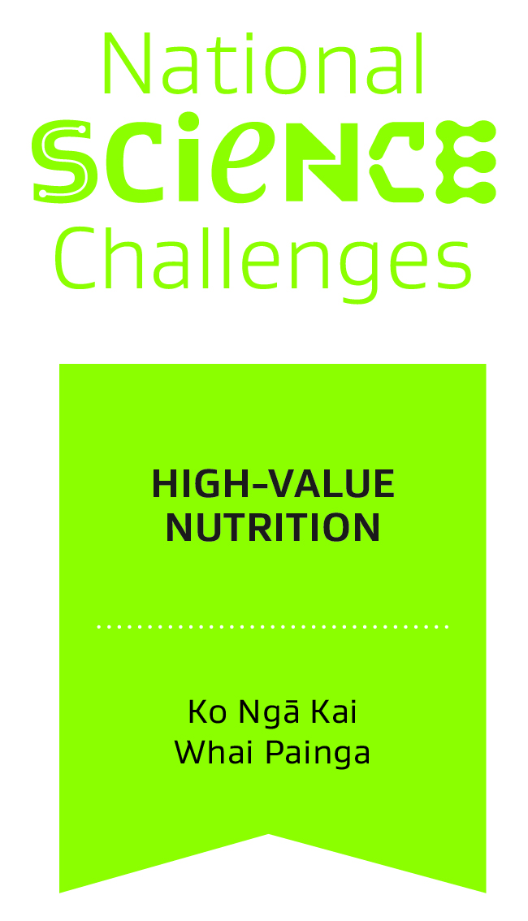
Application for the role of Science Leadership Team member, responsible for Vision Mātauranga
March 2016

Full Name
Affiliations
Name of employing organisation
Contact details for correspondence in relation to this application

Submission
Please complete all sections in this template, remove instructions in italics, save as a PDF and submit to HVN@auckland.ac.nz by noon on 18 April 2016

NOTE: This application template should be read in conjunction with the Call for a Māori member of the High-Value Nutrition Science Leadership Team published on the High-Value Nutrition website and in the March Newsletter
Cover Note
(approximately 1 page)
Please outline the reasons for your interest in becoming a member of the High-Value Nutrition (HVN) Science Leadership Team and the strengths you would bring to the role with a particular emphasis on your understanding of the focus on the indigenous innovation theme of Vision Mātauranga policy within the Challenge (note the focus of HVN is economic via increasing the value of food exports rather than a health focus which is addressed by other National Science Challenges (NSC). Nor is it focused on food production systems which are addressed in the Our Land and Water NSC).
Given the narrow focus of HVN on food and beverage exports (with relatively few Māori owned food and beverage exporting businesses with scale and intent aligned to the HVN mission) provide your ideas on how you would seek to champion Vision Mātauranga across the Challenge with the long term aim of growing Māori participation in the Challenge to create enduring benefits for Māori over time.
Describe the networks that you would be able to bring to the Sciecne Leadership Team and HVN in general and their potential to enhance the performance of the Challenge and ensure it builds two way understanding with relevant Māori stakeholders.

Evidence for Assessment Criteria
(2 pages max)

Your application will be assessed by a small panel including the High-Value Nutrition Science Director (or Chief Scientist) with two colleagues who will be able to assess the Vision Mātauranga elements (these will be advise to applicants once applications are received).

The initial assessment will recommend a short-list for a face-to-face interview with the panel prior to deciding on the final selection. The HVN Board will receive and approve recommendations of the panel.

The panel will consider the following criteria in forming its recommendations:

- Understanding of the Challenge’s mission and the approach to Vision Mātauranga within it. For the Science Leadership Team to operate effectively it will require people who understand the mission of the Challenge and the strategy for implementing Vision Mātauranga.
- Leadership. To make a successful contribution to the Science Leadership Team, demonstrable leadership experience in their area of expertise or the potential for research leadership would be required.
- Māori networks and connections. To effectively raise awareness of the Challenge with key Māori stakeholders and to be able to represent the Challenge effectively, a good network in the Māori research and food and beverage businesses would be an advantage.
- Quality and relevance of potential research ideas. As outlined in following section.
Provide any further evidence relative to these criteria here:

Research Ideas
(1 to 2 pages)
Include some ideas you have for potential research projects that you could lead that both fit within the scope of High-Value Nutrition (See path-to-market diagram below as reference of the research capabilities in scope) and would include or exemplify the Vision Mātauranga theme of indigenous innovation (Note: this could include enagement with innovative Māori-owned food and beverage exporting businesses).

A generic overview presentation on HVN is available on request and provides further information on the priority health target areas
References
Include any relevant references you have that support your application or provide the names and contact details of any referees who can be contacted in relation to this application.

Curriculum vitae
Please include a standard academic cv along with your application.

Conflicts of Interest
Please identify any person or party who may be involved in the assessment of this proposal that you believe would have a conflict of interest and outline the nature of that conflict.
The Chair of the Assessment Panel or the Chair of the HVN Board will determine any actions to be taken in relation to any identified conflicts according to the HVN Conflicts of Interest Policy.

Process
Following approval of a lead applicant by the HVN Board the candidate will be invited to work with HVN to agree a process for development of an original research project that exemplifies Vision Mātauranga within the strategic parameters of the Challenge. This is likely to include working with colleagues and consulting with end users.Any research project developed through this process will be presented to the HVN Board for approval with the successful candidate as Principal Investigator. Following approval a research subcontract will be negotiated with the candidates employing organisation for both the role as a member of the Science Leadership Team and the research project.

Draft Terms or references for the hvn Science leadership team
The current draft TOR for the HVN SLT are available on request

Declaration by Applicant

I declare on that the information contained in this proposal is accurate at the time of submission and that my employing organisation fully supports this application.

Signed by:

Name:

Title and affiliation:

