Exposure of adolescents to food advertising through Facebook in New Zealand

Participant Instruction Sheet

Step 1: Fill out the questionnaire
The questionnaire is online-based. The link of the questionnaire has been sent to you by email.
Please submit the completed questionnaire within two weeks from reception.

Step 2: Become ‘friends’ with ‘Boyd Swinburn’
All participants involved in this study will need to become friends with ‘Boyd Swinburn’. This is the account of the main researcher.

- Search “[Boyd Swinburn]” in your Facebook search window
- Send a request to become friends.
- The researcher will accept the request as soon as possible.
- After completion of the study, the researcher will disconnect all ties with you (‘unfriend’ on Facebook). You can disconnect ties as well after participation in the study.

PLEASE ‘UNFRIEND' WITH 'BOYD SWINBURN' AFTER YOU HAVE SENT THROUGH THE ADVERTISEMENTS.

Step 3: Send food advertisements to the researcher
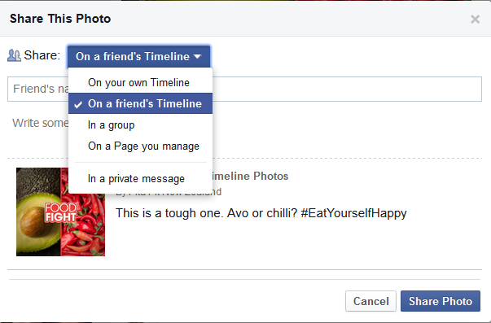
Please post/share on ‘Boyd Swinburn’s’ Timeline (the account of the researcher of the study) ALL food and beverage advertisements within your Facebook newsfeed over the last three days.

PLEASE EXCLUDE THE CURRENT DAY

For ALL food and beverage advertisements (pictures and videos) within your Facebook newsfeed over the last three days:

- Go to your newsfeed page
- Click on ‘share’ ( ) at the bottom of each advertisement of ALL advertisements related to food and beverages in last 3 days (Scroll down the newsfeed to view and share the last 3 days)
- Select at the top ‘On a friend’s Timeline’
- Search and select ‘Boyd Swinburn’
- Enter your participant ID number and click on post to send the advertisements to the Facebook account of the researcher

Please note: If you log on to Facebook without using the Facebook app via your smartphone, STEP 3 will differ. You cannot share the advertisements ‘on a friends Timeline’, instead you will need to ‘share’ the advertisement through a private message to ‘Boyd Swinburn’. The other steps are the same as above.

All advertisements related to food and beverages (brands, companies, events, recipes) should be forwarded, including advertisements that are promoted, advertisements of brands that you did not ‘like’ and advertisements forwarded by your friends appearing in your newsfeed. After saving the advertisements at the research institute, the posts you shared on Facebook will be deleted on the Timeline. The participant ID will be the only link kept after advertisement and questionnaire have been linked.
Please note that the Facebook account ‘Boyd Swinburn’ has been set up so that ONLY the researcher can view what is shared on their timeline by you.
You can also control your privacy settings under ‘settings’ on Facebook.

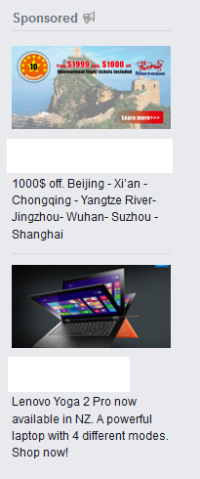
Step 4: Send ONCE a screen shot of panel on the RIGHT SIDE of your Facebook newsfeed
This step is only for those using a computer/laptop or iPad/tablet (without the Facebook App) to log on to Facebook (smartphone/iPad/tablet with Facebook App do not show a panel on the right hand side).

Please post a screen shot ONCE (see screen shot instructions below) on ‘Boyd Swinburn’s’ Timeline of the panel seen (both sponsored food-related and non-food related ads, suggested group etc.) on the RIGHT HAND side your Facebook newsfeed through the following procedure:

- Click on your Facebook newsfeed and view all the panel seen on the right hand side of the newsfeed
- Take a screen shot (this means screen has been copied) of the panel. See screen shot instructions below. Save the image on your desktop
- Search and select ‘Boyd Swinburn’
- On ‘Boyd Swinburn’s’ Timeline upload the image by clicking on ‘photo/video ( ) and enter your Participant ID number which has been allocated to you.
- Two screen shots may be needed to capture all the whole panel.
- This step only needs to be done ONCE even if the content of the panel changes

PLEASE ONLY SEND US THE ADVERTISEMENTS
DO NOT SEND US ANY PERSONAL INFORMATION
Screen shot instructions
For Computer/laptop users:
- Take a screen shot by pressing PrtScn or PrintScr on your keyboard (how it is written will vary on keyboards)
- Open Paint program and paste the image. Crop the image so that only the advertisements are seen.
- Save the image on your desktop/folder, ready for upload on Facebook

To learn how to take a screen shot click on the link below:
For PC/laptop users: http://www.youtube.com/watch?v=3-SY1sM13Qo
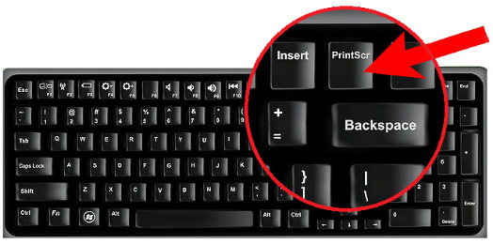

For Mac computer users: http://www.youtube.com/watch?v=h3RkDPfphSQ
- Take a screen shot by pressing command + shift + 4 together
- Select the area to want to copy with your mouse
- The image will be saved on your desktop

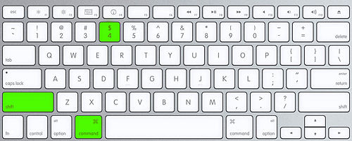

For iPad or Tablet (when not using the Facebook App) users:
ipad and Samsung Galaxy Tab 3 :
- Find the image you want to capture in this case the advertisements. The screenshot function will capture everything that is currently being displayed on your phone, including the buttons on the bottom.
- Locate your Sleep/Wake/Power button. This button is on the top right of the iPad or on the side for Samsung galaxy Tab.
- Locate your Home button. This is the button that's centered on the bottom of your iPad or Samsung galaxy Tab.
- Hold down the Sleep/Wake/Power button, and while holding it, press and release the Home button. Then you can release the Sleep/Wake button (this can be a moment later).
- Confirm that you've captured the image. Just look through your Camera Roll/gallery to see if the image appears there.
- Crop the image to only capture the advertisements, ready for upload on Facebook

Other Tablets:
- Find the image you want to capture in this case the advertisements. The screenshot function will capture everything that is currently being displayed on your phone, including the buttons on the bottom.
- Different devices use different buttons. Most every device that supports screenshots uses one of these methods.
- Power and Home button
- Power and Volume Down button
- Home button and volume down button

To learn how to take a screen shot click on the link below for:
- Samsung Galaxy Tab 2: https://www.youtube.com/watch?v=cvaX9U7GN3c
-Press the power button and volume down button
- Windows: https://www.youtube.com/watch?v=fJ9JBRYGJ4A
- Press the Windows home button and volume down button

- Confirm that you've captured the image. Just look through your Camera Roll/gallery to see if the image appears there.
- Crop the image to only capture the advertisements, ready for upload on Facebook

Thank you for taking your time to follow the instructions

For any queries or more information contact us on:
Email: informasgroup@gmail.com
Telephone: 099238489

