

The PlexSet-12 Kits allow you to analyse 12 RNA targets of interest across a maximum of 88 samples in a single run (remainder of 96 sample chip is used for controls etc). The Technology uses off the shelf barcoding reagents that combine with your targets of interest via a universal tag sequence. This forms a complex that can be counted by reading of the barcode. Yes counting a single molecule!



All you need to do is order oligos for your 12 targets of interest with the universal tag sequences. Nanostring have a very user friendly design protocol for oligo synthesis. When your oligos arrive send them to GCG with your extracted RNA samples (Require at least 300ng RNA) in multiples of 8 (minimum 8 + 1 maximum 88 + 1 Reference sample and your project will be run) Larger projects will be considered on a case by case basis.

An example of how we set out the plates is shown below. Samples for each project (your probe set A+B = Probe set 1) are set up in columns down the plate allowing multiple projects to be run on a single plate.

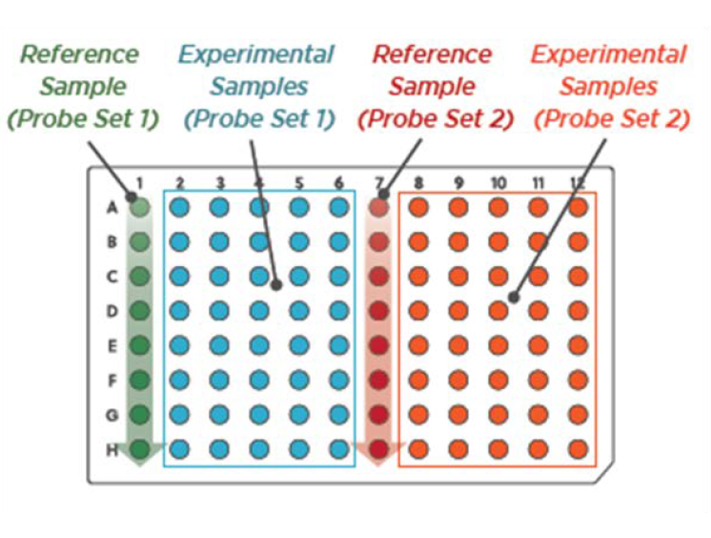

In order to get the best results possible a Titration run may be needed to determine the optimum RNA input. This will test a reference sample and one other at varying RNA input levels to calculate an optimum input. We have titration kits that can be given to winning proposals if deemed necessary.

If you have any questions about the PlexSet-12 run please contact Jason Copedo either by email: [j.copedo@auckland.ac.nz](mailto:j.copedo@auckland.ac.nz) or phone: 0210437900.