Types of Displays Used for Analysis

In this document we will cover types of data display we recommend. It is intended for anyone who wants to make sense of their data.

There are four main categories which you can choose from once you have decided what you would like to show. They are:
- Composition
- Comparison
- Distribution
- Relationship

Composition

Pie Chart: Shows static data

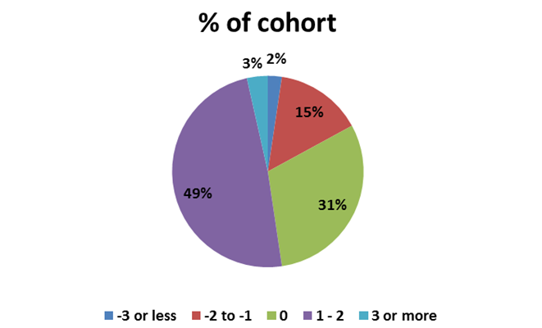

Stacked column chart: Good when there are only a few items over time

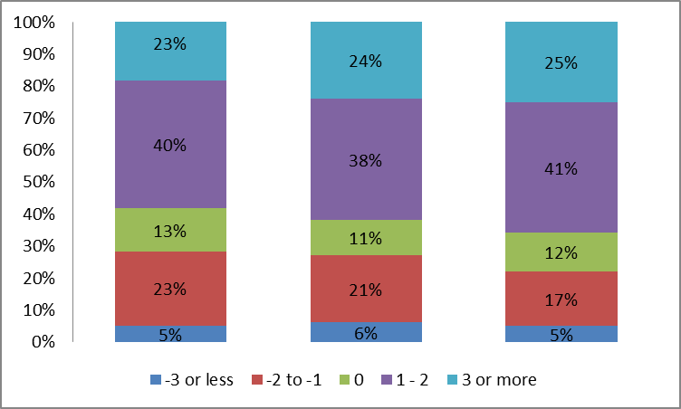

Comparison

Tables: Great for when there are many categories being compared

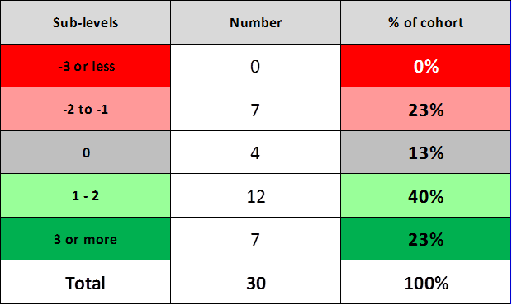

Bar Chart: Good when there are many items

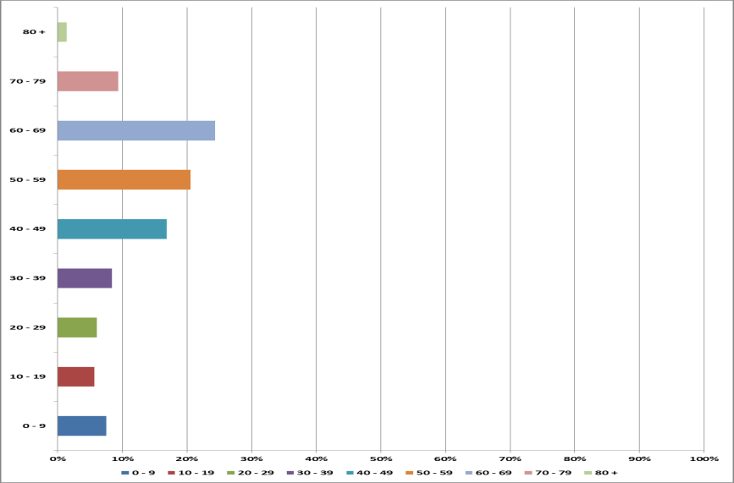

Column Chart: Good when there are only a few items

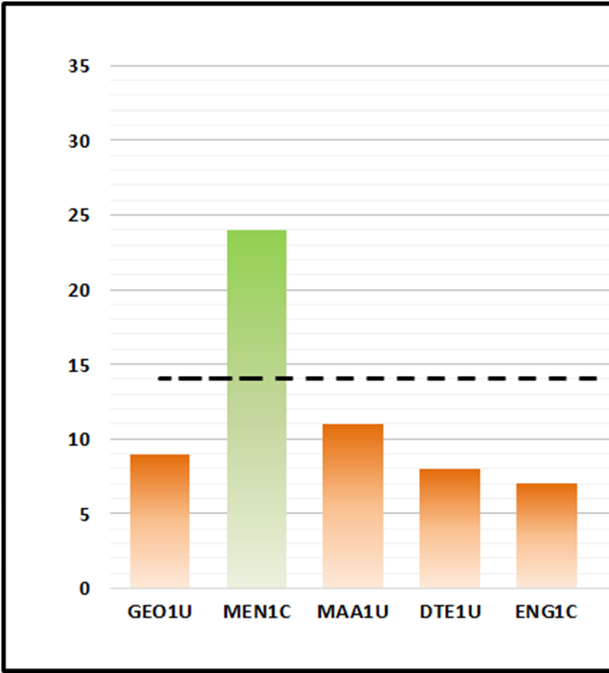

Box and Whisker chart:

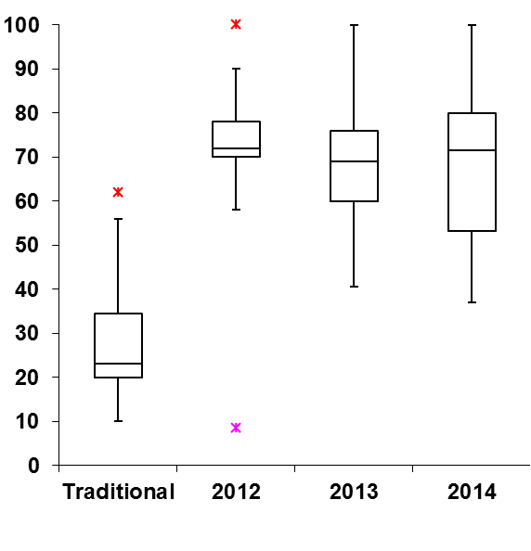

Line (Time Series) chart: Great for data that is changing over time

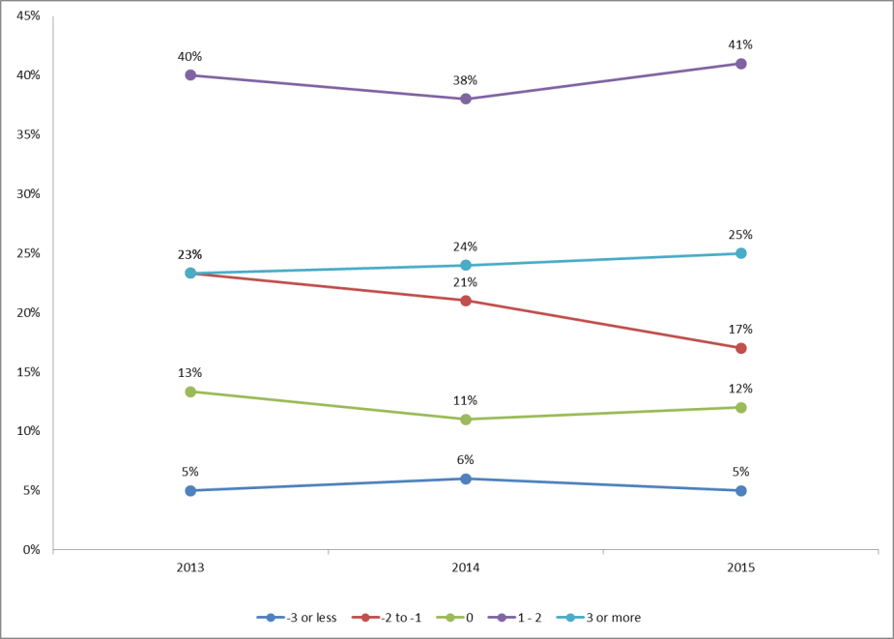
Distribution

Column histogram:

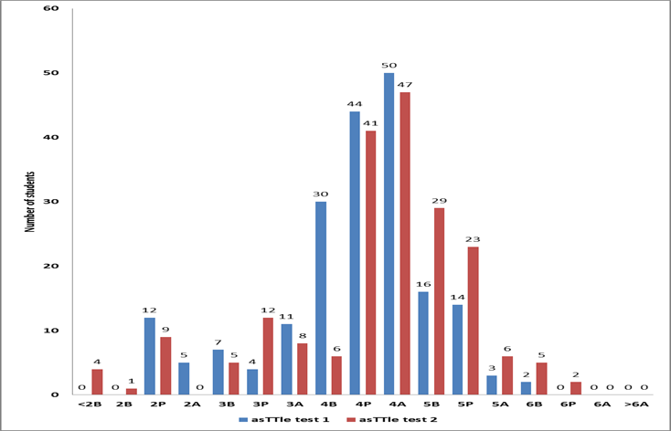
Relationship

Scatter plot: Great for using to see if there is a relationship between two variables.

