Handling Data with EXCEL: Pivot Tables and Graphs

This document is intended for any teacher wanting to summarise their data, and especially for SAMs. Understanding pivot tables and graphing data should be standard skills in data use in schools.

In this session we will cover:
- Pivot tables
- Graphing data

These are not comprehensive notes. You can also find good demonstrations of these techniques on YouTube.

Pivot tables
Go to Insert>Pivot Table

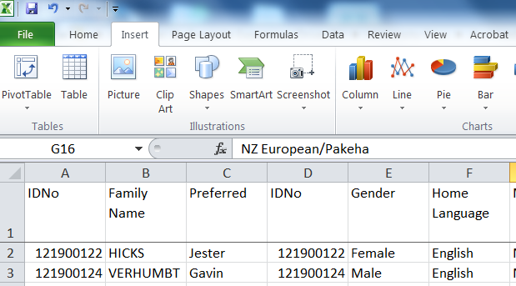

This brings up the Pivot Table Wizard
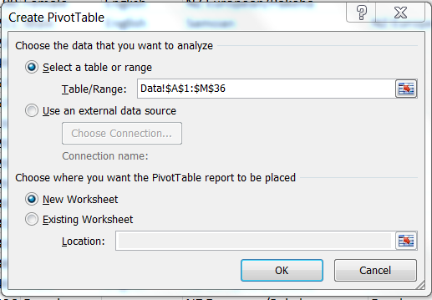

Choose the data you want to analyse.
To do this, use your mouse to highlight all the columns that you want to summarise (in this case, columns A to M). You should see the ‘ant trail’ around those columns.
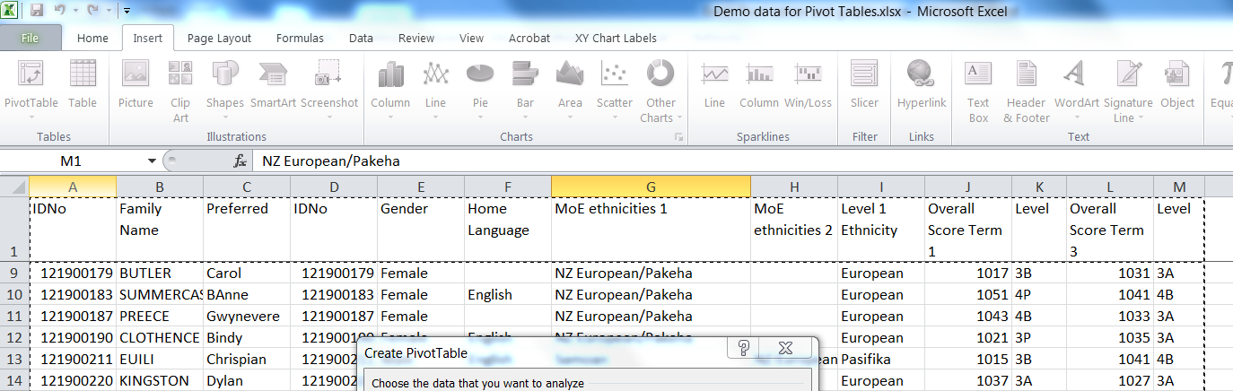

Click OK. A box will appear on the left and right of the screen. The one on the left is where the pivot table will go, and the right is where you are going to design your table.

Start with the boix obn the right. From the list on the right, drag Level 1 Ethnicity to the part of the diagram labelled ROW LABEL. Note that not all of the labels will appear on screen, and that Level 1 Ethnicity is ticked and in bold in the list of columns available.
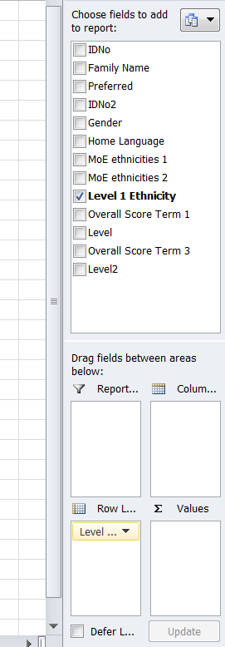

At this stage, the Pivot Table is starting to be built on the left of the screen – in this case, the five ethnic groups in our data.
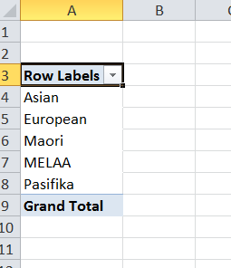

Now drag Family Name to the VALUES box. All you will see is “Count of”, but if you hover your mouse over the “Count Of”, it will show you that this is a Count of Family Name.

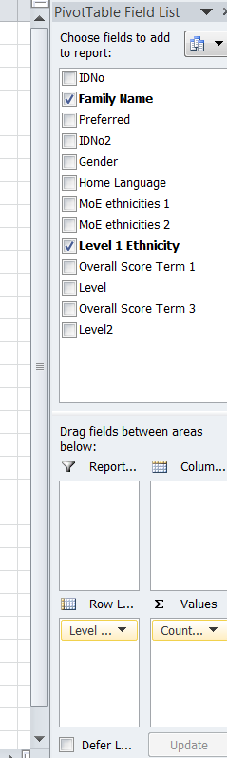

The table on the left now looks like this. It has a count of how many students there are in each ethnic group.

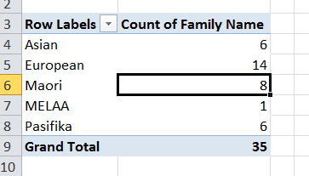

How about showing the asTTle sub-levels for each ethnic group on the Term 1 test?
Drag the first of the two Level labels in the list to the Column box.
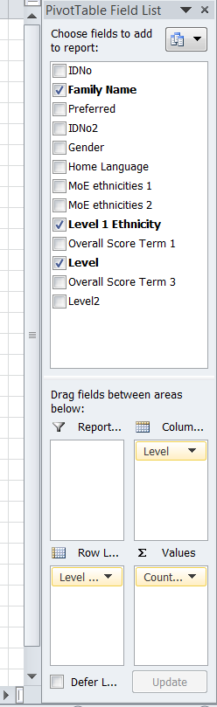

The table on the left now looks like this.

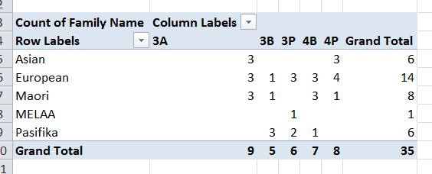
The Grand Totals are the same as above, but you now have how many students in each ethnic group obtained a given asTTle sub-level.
Darn, I hear you say – the sub-levels are not in the right order i.e., 3B, 3P, 3A, 4B etc.

Let’s move the offending column (in this case, the 3A), and fix that. Type 3A over the heading label of 3P. The columns now move so that they are in order: 3B, 3P and 3A.
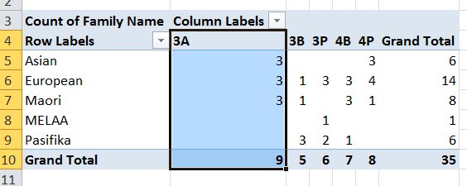
Now hover your mouse over the edge of the outline until a four arrowed cross appears. Click and hold while this cross is visible, and drag the highlighted column to the right and ‘let go’ after the 3P column. Voila, it is now in the right place.
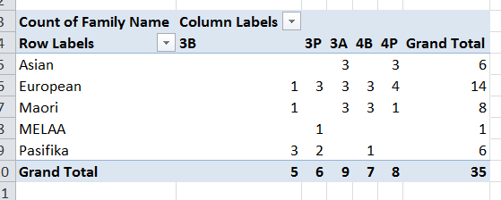

You can tidy up the screen – for example, centre all of the data and headings so they line up.
Highlight all of the columns except the first. 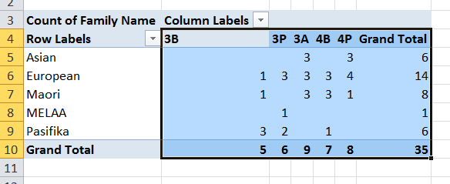

Click on the Centre Alignment icon.
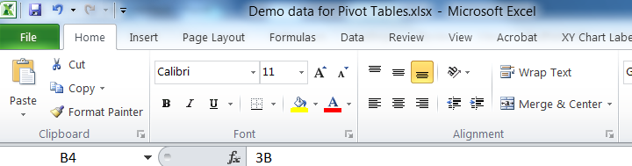

Et voila!
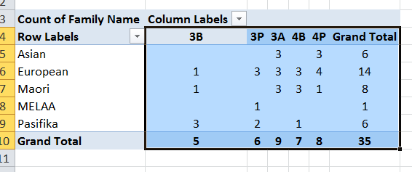

How about converting these numbers to percentages so they can be used for comparing with other data sets?
Click on the Count of in the Values box in the bottom right of the table set-up, and a little dialogue box pops up above.
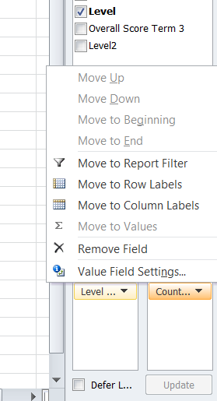

Click on Value Field Settings.
Another dialogue box pops up.
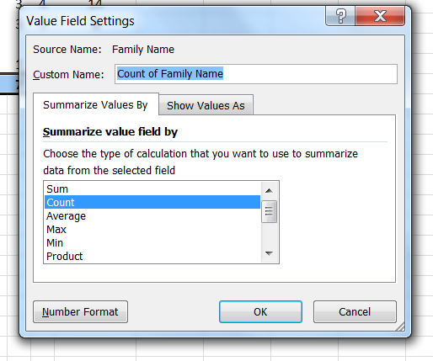

Click on the Show Values As tab, and click on the little arrow on the right of the box with No Calculation in it.
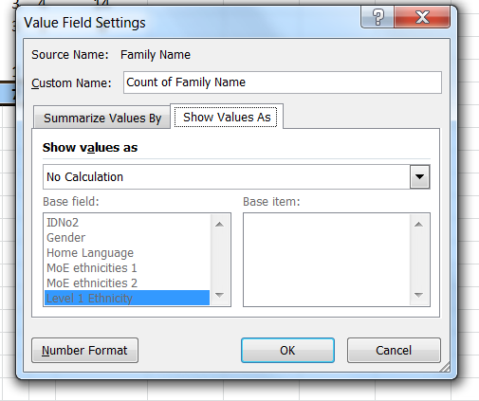

Some options for showing percentages appear – choose the one labelled % of Row Total, and click on it.
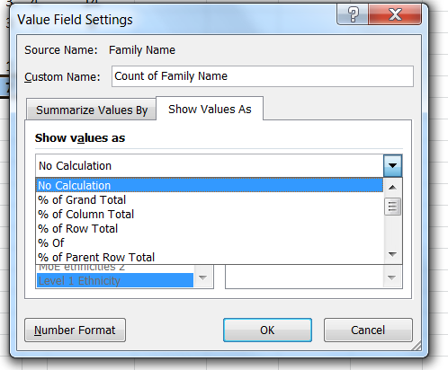

Click OK, and the table now has percentages showing for each row.

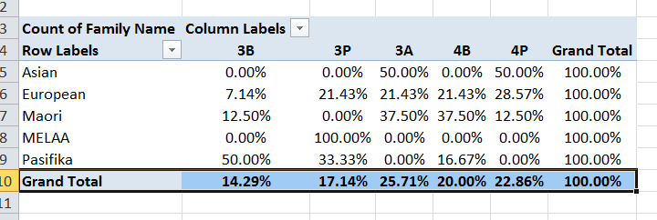

Too many decimal places? Let’s fix that too. Highlight the columns from 3B to Grand Total in the table.
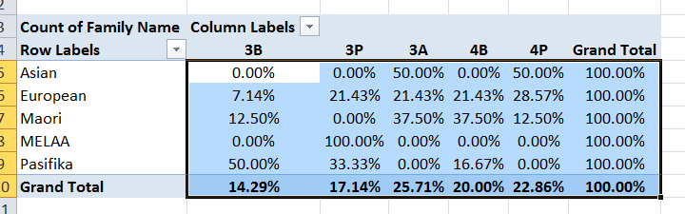

Click on the decrease decimals places icon in the Alignment section of the tool bar – each click on this icon will decrease the number of decimals places by one.
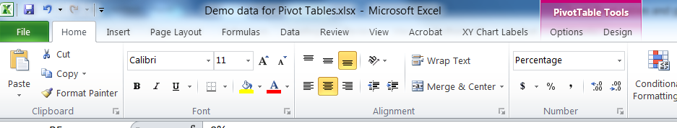

The table is now ready to use – for example, copy and paste to a Word document for a Board report.
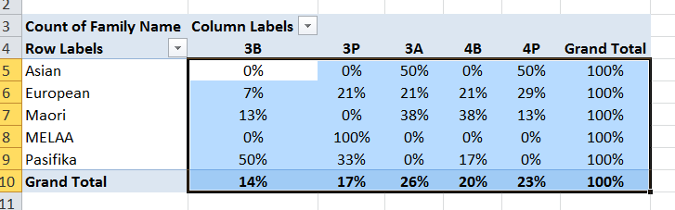

Now create a similar Pivot Table for the Term 3 data column.

The final product should look like this.

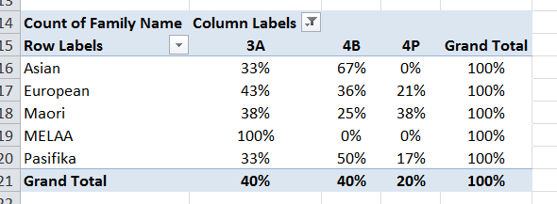

Spend some time experimenting by dragging and dropping the various fields to different places on the table builder. What happens to the table if there are two fields in one box? For example if the table builder looks like this?

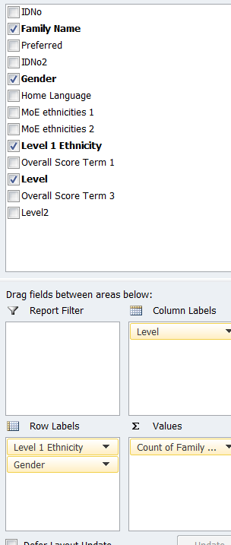
What happens if you drag and drop something in the Report Filter box?

Graphs of the data
Let’s create a graph that shows the sub-levels for both terms for all students, not for the ethnic breakdown. The final graph will look like this:

It is best to start with the data summarised and organised into a single table like this:
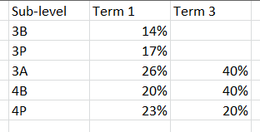

Click on Insert > Column
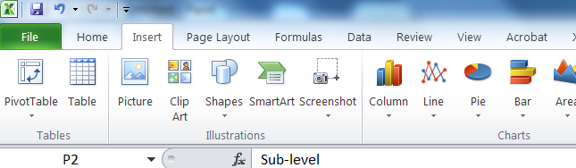

You will get the following dialogue box. Click on the top left-most image.
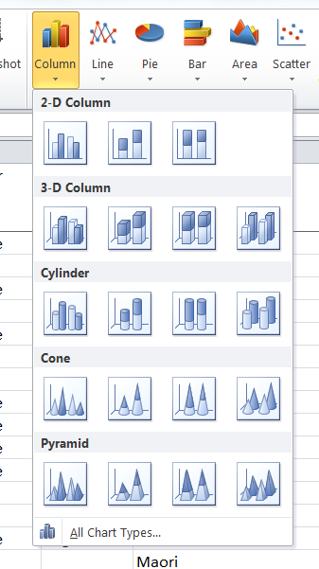

The graph you want should now appear – but it might not be where you want it. You can copy and paste it to a Word document, or shift it around the spreadsheet by clicking on the outline and dragging it to the desired location.
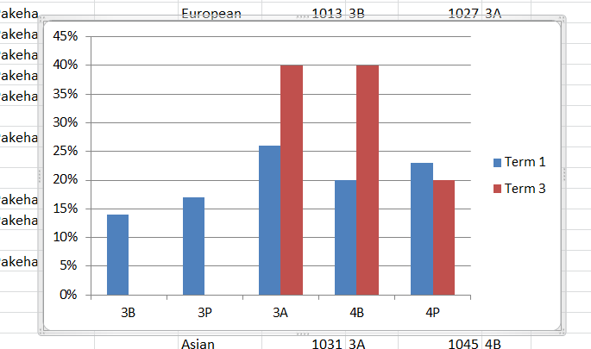
You can dress up the graph by adding axis labels, and a graph label.
With the graph still highlighted, you will notice that there is a set of Chart Tools highlighted in the tool bar. Choose the Layout tab.

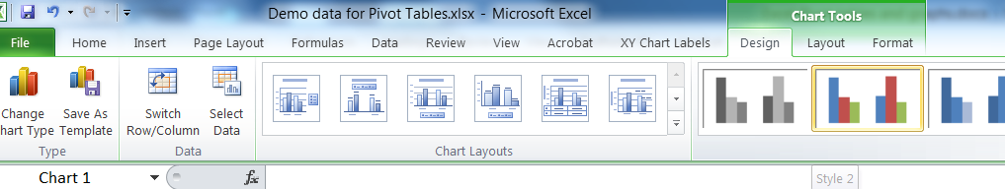
You can adjust the Chart Title, and Axis Titles quite easily.
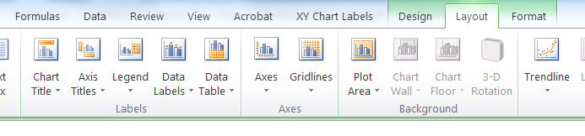

Click the Chart Title and choose Above Chart.
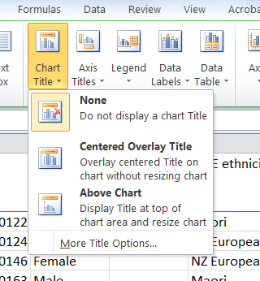

The text Chart Title will appear in a box above the graph, so go ahead and type the heading that you want – it will appear in the formula bar, and when you press Enter, it will appear above the graph.
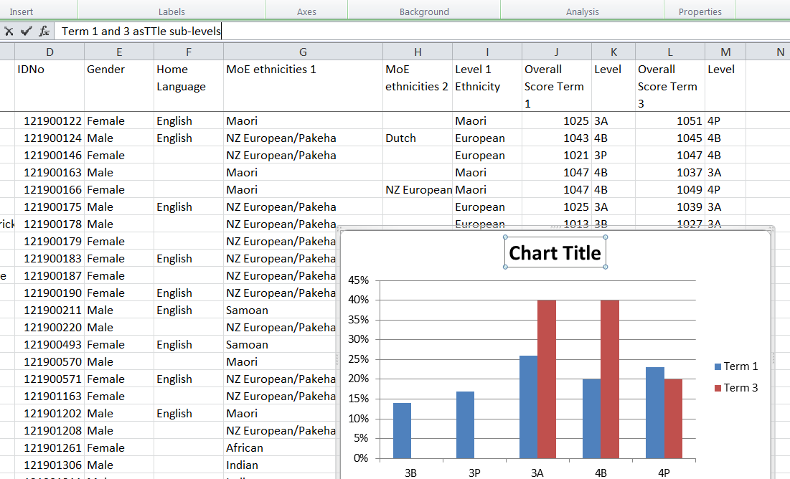

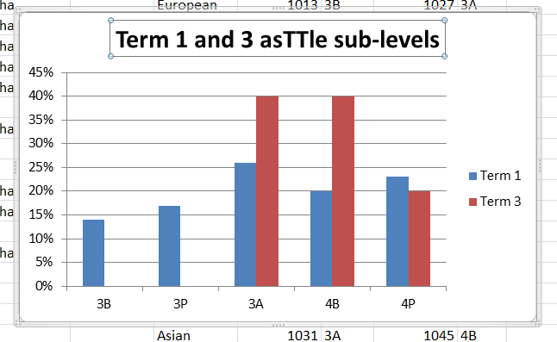

Finally the axes.
Horizontal axis – click Title Below Axis, and type the label you want. This will again appear in the formula bar, and when press Enter, will appear below the axis.
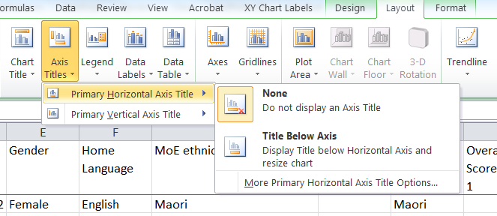

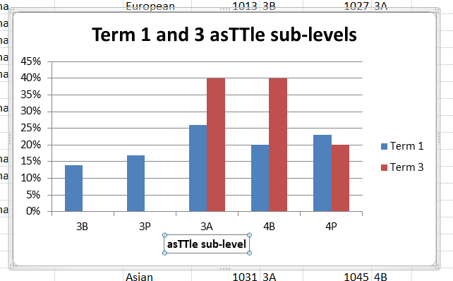

Now try to label the vertical axis.

How about drawing the graph for ethnicity by Term 1 sub-levels? You already have the percentages you need in the pivot tables above.
Now ethnicity by Term 3 sub-levels?

