Starpath Quality Assurance Checklist: three way conversation

Focus/content:
  - Student goals: short medium long term

  - Specific targets: ……………………………………………………………………………..

  - Achievement: past current future

  - Subject choices: ……………………………………………………………………………..

  - Study issues: positive mixed negative

  - Family involvement: …………………………………………………………………………..

  - Decisions/actions before next PST: ………………………………………………………..

  - Attendance: positive mixed negative

  - Other behaviours: positive mixed negative

  - Other (e.g. personal touch): ……………………………………………………………………
Data based: profile targets (TL) credits

Interactive: 3-way 2-way TS TP SP
Quality: engaging perfunctory uneasy/tense

Effectiveness: Q answered issues clarified decisions made

Summary evaluation:
3-way talk
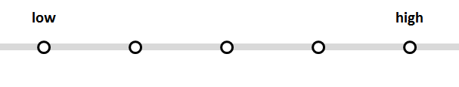
Data-based
Individualised
Achievement- focussed

Printed information given to parent/student:

Any other observations/comments:

